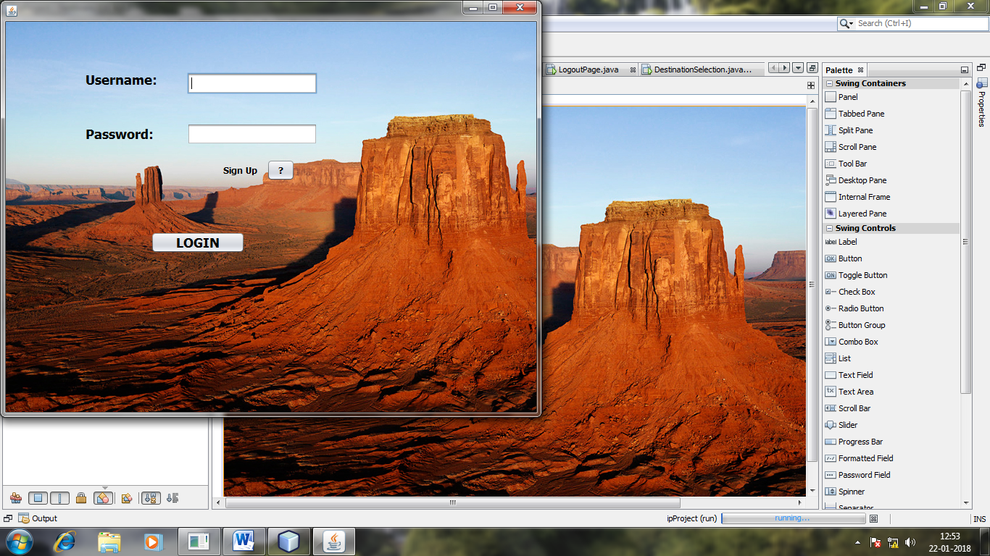

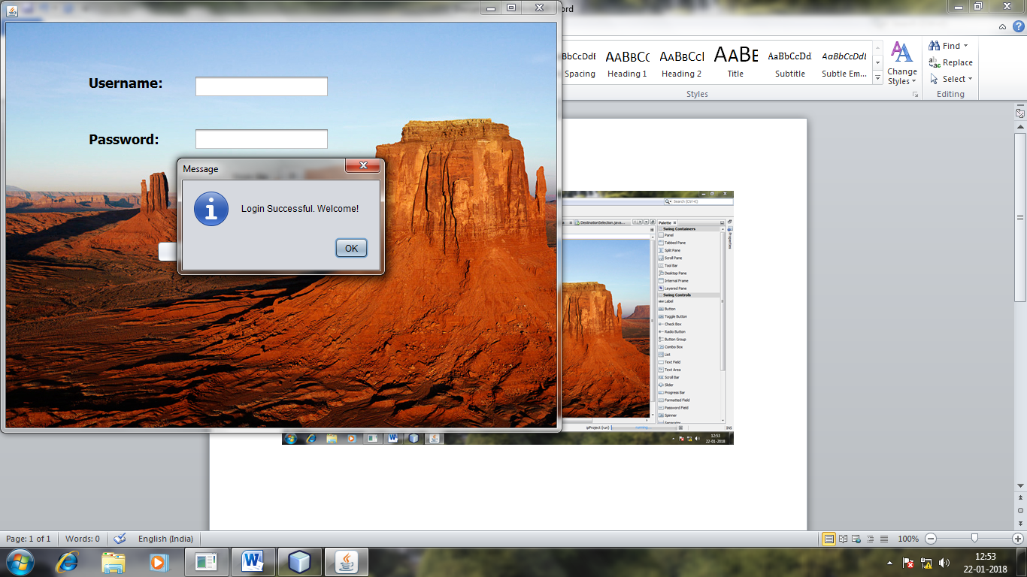

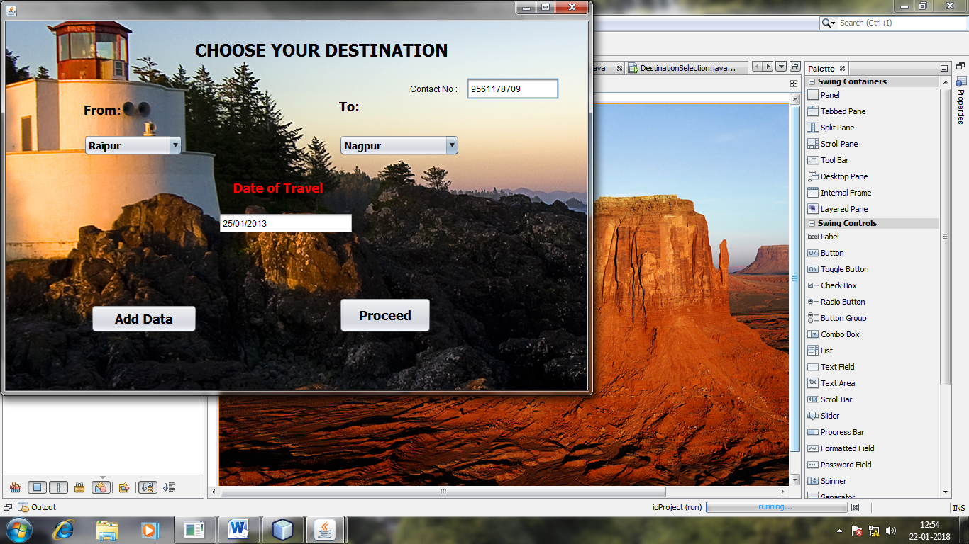

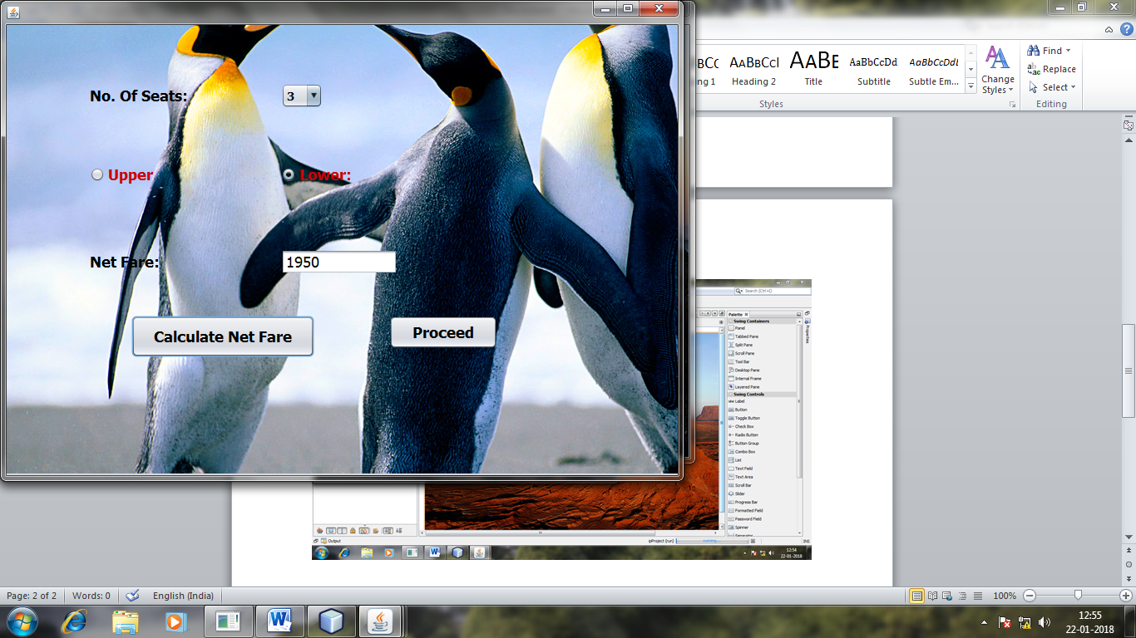

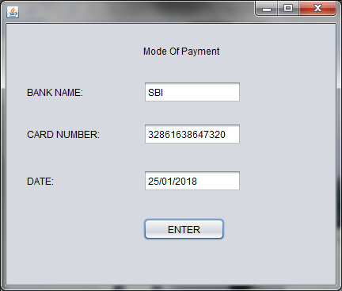

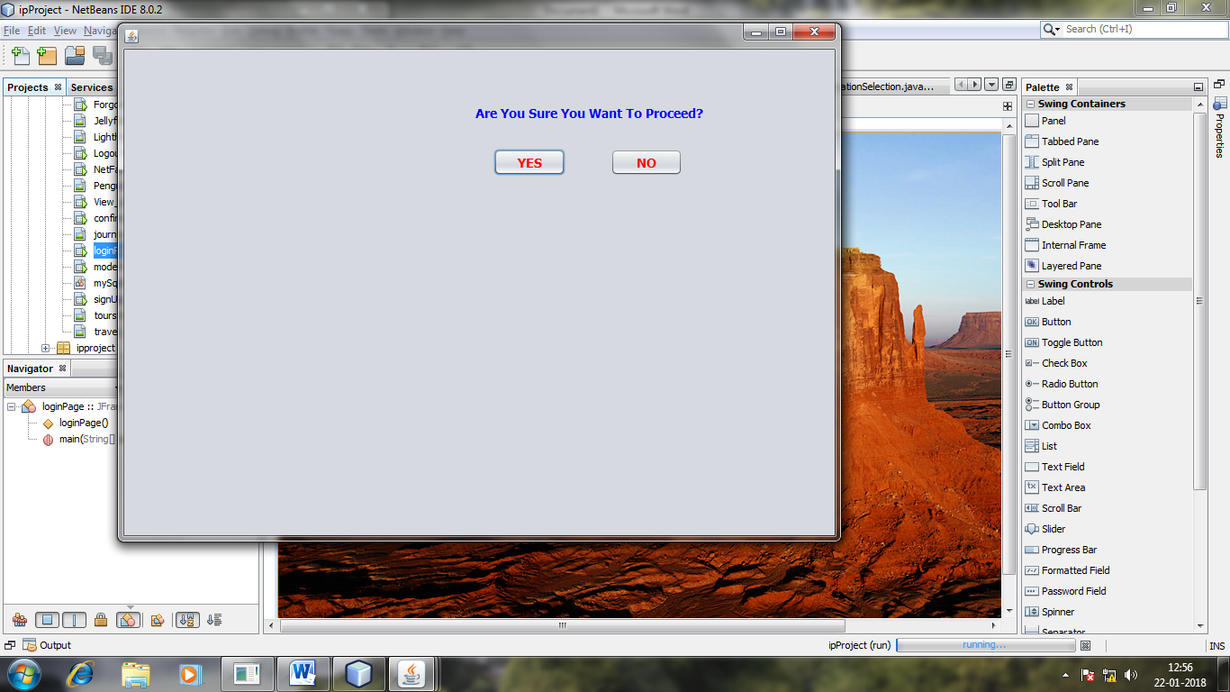

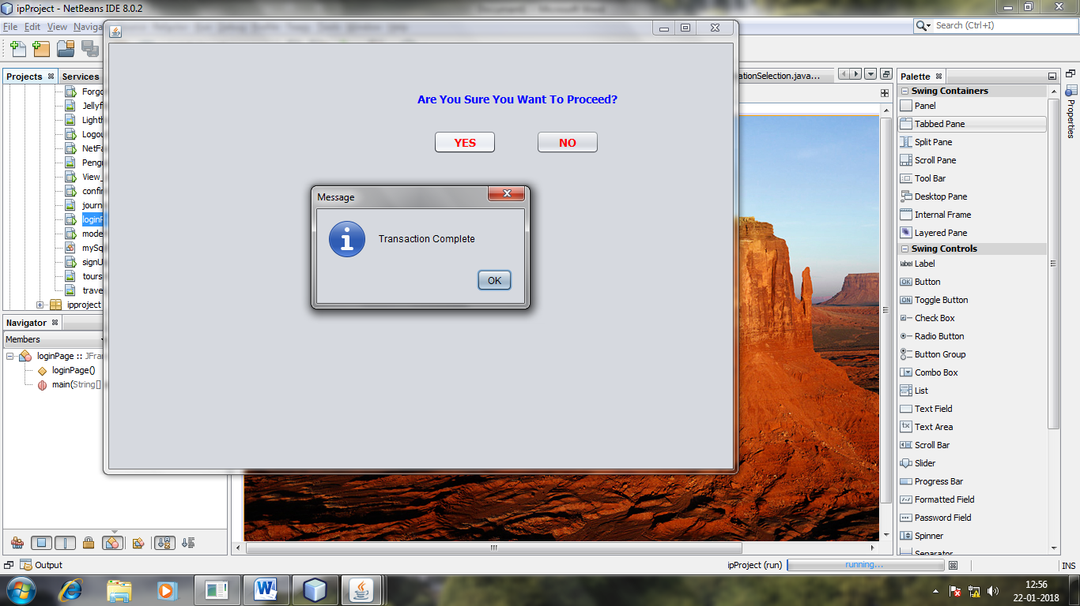

View details

String contactNo= jTextField1.getText();

try

{

Connection con = mySqlDBConnection.getConnection();

Statement stmt = (Statement) con.createStatement();

String query="SELECT From_, To_, Date_Of_Journey, FROM signup, Journey WHERE Signup.Contact_No = Journey.Contact_No and Contact_No= '"+contactNo+"'" ;

ResultSet rs =stmt.executeQuery(query);

DefaultTableModel model = (DefaultTableModel) jTable2.getModel();

while(rs.next())

{

String From =rs.getString("From_");

String To =rs.getString("To_");

String Date1 =rs.getString("Date_Of_Journey");

model.addRow (new Object[] {From, To, Date1});

}

}

catch (Exception e)

{

JOptionPane.showMessageDialog(this, e.getMessage());

}

}

Login

String lUsername, lPassword;

lUsername= loginUsernameTf.getText();

lPassword= loginPasswordTf.getText();

loginUsernameTf.setText("");

loginPasswordTf.setText("");

try

{

Connection con = mySqlDBConnection.getConnection();

Statement stmt = (Statement) con.createStatement();

String query="SELECT 1 FROM signup WHERE Username='" + lUsername + "' AND Password='" + lPassword + "'";

//System.out.println(query);

ResultSet rs = stmt.executeQuery(query);

if(!rs.isBeforeFirst()){ //rs.isBeforeFirst() is true if the cursor

//is before the first row. If rs contains

//no rows, rs.isBeforeFirst() is false.

JOptionPane.showMessageDialog(this, "Login Failed. Please try Again!");

}

else{

JOptionPane.showMessageDialog(this, "Login Successful. Welcome!");

new DestinationSelection().setVisible(true);

}

}catch (SQLException e){

System.out.println("Error in mySQL Query");

}